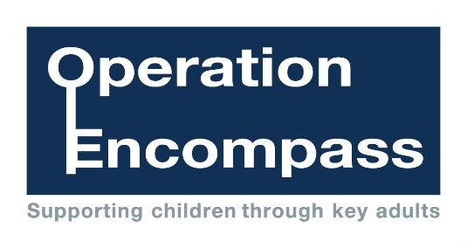
Friday 16th December 2016

Dear Parents/Carers,

Re: Wigan Encompass

Our school has been given the opportunity to take part in a new project that will run in partnership with Wigan Safeguarding Board and Greater Manchester Police.

The project, Wigan Encompass, has been designed to provide early reporting to schools of any domestic abuse incidents that occur outside of school but which might have an impact on a child attending school the following day. This information will be shared on school days during the school term. When incidents occur on a Friday, Saturday or a Sunday, the police will contact the relevant school the following Monday.

A nominated member of school staff, known as a Key Adult, will be trained to liaise with the police. At St. Wilfrid’s Church of England Primary Academy our Key Adult is Mr. S. Colothan. They will be able to use information that has been shared with them, in confidence, to ensure that the school is able to support children and their families. Information will be shared where it is identified that a child or young person resides at an address where a domestic abuse incident took place.

We always endeavour to offer the best support possible to our pupils and believe that Wigan Encompass is going to be beneficial and supportive for all concerned children and families
Some information about Encompass is included in this letter but if you would like more information about this new initiative, details can be viewed online at http://www.saintwilfrids.wigan.sch.uk/ or you can contact our Key Adult at school.

Thank you for your continued support.

Yours sincerely,

Rector Andrew Holliday Mr. S. Colothan
Chair of Governors Headteacher

